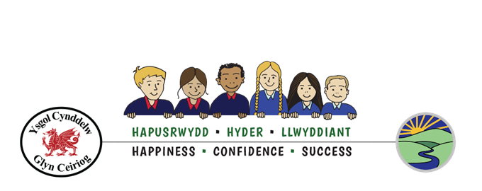

Ffederasiwn Dyffryn Ceiriog
Ceiriog Valley Federation

Grievance Policy
_______________________________________________

Approved by Governing Body on | Date: November 2021
Due for review on | Date: January 2024
Signed by Chair of Governing Body | C. Davies
(Print name) | Mrs Carys Davies

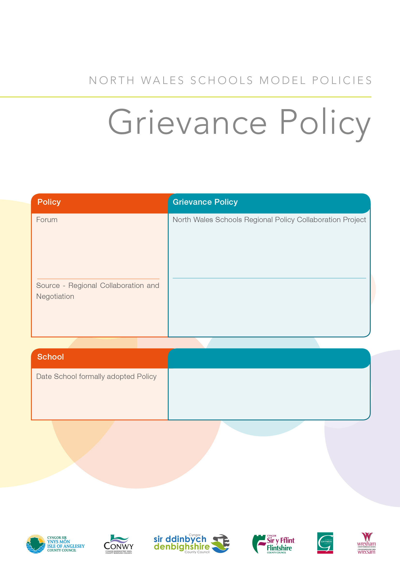
Ceiriog Valley Federation / Ffederasiwn Dyffryn Ceiriog
Ysgol Cynddelw & Ysgol Llanarmon Dyffryn Ceiriog
25/11/21

Insert School Name

Document Control

Overview
POLICY | Grievance Policy
OWNER | North Wales Regional HR Group (Schools)
NOMINATED CONTACT | Sian Croston (sian.croston@flintshire.gov.uk) HR Policy & Reward Advisor
REVIEWED BY | North Wales Regional HR Group  North Wales Regional Trade Union Representatives
DATE OF LAST REVIEW | February 2018
DATE OF NEXT REVIEW
RELATED DOCUMENTS | School’s Disciplinary Policy  Dignity at Work Policy  Schools Complaints Procedure  EIA CCS/EIA/00195/2018

Revision History
Version | Issue Date | Author | Summary of Changes

Consultation
Version | Who | Date
V1 | Regional Collaboration Group consisting of HR Representatives from all Authorities & Trade Union Regional Representatives from all recognised Trade Unions approved this version | February 2018

Contents
Document Control 3
1.0 Grievance Policy and Procedure 5
1.1 Purpose 5
1.2 Scope 5
2.0 Policy Principles 5
3.0 Roles and Responsibilities 6
3.1 The Chair of Governors is responsible for: 6
3.2 The Headteacher/Designated Manager is responsible for: 6
3.3 The Governing Body is responsible for 7
3.4 Employees are responsible for: 7
4.0 Informal Procedure 7
5.0 Formal Procedure 9
5.1 Step 1 – Raising a Formal Grievance 9
5.2 Step 2 – Investigating a Grievance 9
5.3 Step 3 – Formal Grievance Meeting – Stage 1 9
5.4 Step 4 – Formal Grievance Appeal – Stage 2 10
6.0 Headteacher Grievance 11
7.0 Collective Grievance 11
8.0 Employee complaint against the School’s Governing Body 12
9.0 Grievance from former employees of the school 12
10.0 Vexatious Grievance 12
11.0 Grievances and Other Procedures 13
12.0 Records 13
13.0 Monitoring and Review 13

1.0 Grievance Policy and Procedure

1.1 Purpose

Grievances are concerns, problems or complaints that employees can raise with their employers. Anybody working in an organisation, at some time, may have problems or concerns about their work, working conditions or relationships with colleagues that they may wish to talk about with management.
The purpose of this procedure is to enable a grievance to be resolved fairly, consistently, quickly and as near to its point of origin as possible.
This policy sets out:
- Lawful, non-discriminatory, fair and effective arrangements for dealing with employee concerns and grievances.
- Employee responsibilities when raising problems and concerns.
- Headteacher responsibilities for the resolution of issues quickly and consistently in order to maintain good working relationships.

1.2 Scope

This procedure is appropriate for all staff employed by governing bodies, or their employment is regulated by them, including the Headteacher, permanent, temporary, full and part time employees. This procedure is not applicable for those who are employed directly by the Local Authority, agency support staff or those who are self-employed.

2.0 Policy Principles

2.1 Any employee may raise a grievance under this procedure and all employees will be treated respectfully, fairly and consistently. The school will take seriously any reported grievance and employees who have genuine grievances are encouraged to raise them without fear of recrimination.
2.2 Where appropriate, every effort will be made to address concerns without recourse to formal procedures.
2.3 All grievance matters and investigations will be treated in confidence by all parties involved through every step of the process.
2.4 Where necessary, the grievance will be investigated by an impartial and independent person who has no connection to the complaint.
2.5 All meetings at every stage of the procedure should be arranged as soon as possible and within the timescales noted within the policy.
2.6 All employees have the right to be accompanied by a work based colleague or Trade Union representative during formal meetings as part of this procedure. Consideration will be given to allowing representation, by agreement of all parties, by Trade Union Representatives at the informal stages of the procedure.
2.7 The complainant has the right to appeal if they remain unsatisfied at stage one.
2.8 Reasonable adjustments will be made if the employee has a protected characteristic as defined under the Equality Act 2010.
2.9 There may be occasions where it is not immediately apparent that issues raised under the Grievance Policy, should be addressed under this procedure. In some circumstances it may be appropriate to refer and investigate the issues under a different policy, for example:
- Dignity at Work Policy
- Capability Policy
- Attendance Management Policy
- Disciplinary Policy
2.10 The Headteacher will consider all grievances raised by employees, except those grievances that the Headteacher has prior involvement in or are in relation to them, in which it will be considered by the Chair/Vice-Chair of the Governing Body.
2.11 A grievance should normally be raised within 3 months of:
- The occurrence of the incident about which the employee is aggrieved.
- The date the employee first raised it informally with no satisfactory resolution. This is presuming that the employee initially raised the issue within 3 months of the incident occurring.

Historical grievances will be considered if they are related to a current grievance that is being dealt with and meet the criteria above.

3.0 Roles and Responsibilities

3.1 The Chair of Governors is responsible for:

- Ensuring all grievances are taken seriously and dealt with fairly, consistently and sensitively.
- Owning the grievance procedure (if a grievance is raised in connection to the Headteacher), ensuring that it proceeds within the timescales laid out in this policy.
- Notifying the Headteacher, when an informal or formal grievance has been raised in connection to him/her or a decision he/she has made.
- Ensuring that the grievance procedure is followed correctly, seeking advice, when required from the School’s Local Authority HR representative and ensuring relevant parties to the grievance have access to relevant information regarding the grievance in order to respond.
- Ensuring all records of investigations are sent to the Local Authority HR department to be placed on the appropriate files in line with Data Protection legislation.

3.2 The Headteacher/Designated Manager is responsible for:

- Ensuring a working environment where all employees are aware of the grievance procedures.
- Ensuring that all employees within the schools are supported and assisted in resolving issues they have in terms of their employment.
- Attempting to resolve all issues informally before they become formal grievances.
- Treating all grievances seriously, dealing with each one fairly, consistently and sensitively.
- Owning and taking responsibility for the grievance process for all employees and ensure that it proceeds within the timescales detailed in this procedure.
- Notifying the relevant employees, when an informal or formal grievance has been raised in connection to them or a decision they have made.
- Appointing a suitably trained/experienced investigating officer.

3.3 The Governing Body is responsible for

- Adoption of the Policy and Procedure.
- Any arrangements associated with the coordination and governance of Governor Committees taking decisions in relation to this policy and procedure.
- Hearing Appeals against grievance outcomes.

3.4 Employees are responsible for:

- Seeking to resolve issues informally before raising a formal grievance.
- Engaging with the Headteacher/designated manager to genuinely seek a resolution to a grievance.
- Cooperating in any investigation that is carried out.
- Attending all grievance meetings.
- Maintaining confidentiality.

4.0 Informal Procedure

If a grievance involves another employee, the school encourages employees to seek personal resolution by making a direct approach to the employee concerned. If this is not possible, or the grievance does not involve another employee, they may discuss the issue with the headteacher or any other relevant employee/line manager to see if the matter can be resolved informally without invoking the formal procedure.
Where a grievance is brought against another employee, it may be appropriate for the headteacher to discuss their actions/inactions with them as part of their normal supervisory arrangements and without recourse to the formal procedures. This may take the form of advice, counselling, training, instruction, coaching or other managerial strategies as appropriate. Such activity may also be delegated to a member of the leadership team. In respect of the headteacher, this will be carried out by the Chair of Governors with support and advice from their HR representative.
The main purpose of this way of working is to resolve the grievance as soon as possible and as close as possible to the situation that has caused concern.
Headteachers/managers, Governors and employees should always seek to resolve grievance issues in the workplace, however where this is not possible, they should consider using an independent third party to help resolve the problem. Mediation/conciliation can therefore be considered to try and resolve the situation informally. If this is the case, the school should contact their Local Authority HR representative for advice.
Mediation is a voluntary process where the mediator helps two or more people in dispute to attempt to reach an agreement. Any agreement comes from those in dispute, not from the mediator. The mediator is not there to judge, to say who is right or wrong or to tell those involved what they should do. The mediator is in charge of the process of seeking to resolve the problem.
It may be helpful, where all the parties agree, that employees may be accompanied by trade union representatives or work colleagues during mediation to assist in the process.

5.0 Formal Procedure

5.1 Step 1 – Raising a Formal Grievance

When grievances are not resolved to an employee’s satisfaction at the informal stage or if the complaint is considered sufficiently serious, the employee can raise a formal grievance.
To raise a formal grievance, employees must complete a ‘Notice of Grievance’ form (appendix 2) and submit the form and any relevant evidence/documentation to the Headteacher (or directly to the Chair of Governors where the Headteacher is connected to the grievance or is the complainant).
The formal grievance should include the following:
- The nature of the grievance – what is alleged to have occurred.
- Actions taken to resolve the matter informally and the reason for dissatisfaction with the informal solution (if appropriate).
- The outcome the employee is seeking and how this might be achieved.
- Any witnesses to the matters complained about.

5.2 Step 2 – Investigating a Grievance

If the Headteacher/Chair of Governors is of the opinion that the concern falls within the remit of the grievance procedure and an investigation is appropriate, then an investigation should be undertaken as soon as possible by the headteacher or allocated suitably trained/experienced investigator (e.g. a member of the management team/headteacher/governor). If the size of the school or the number of employees makes this impractical, advice should be sought from the Local Authority HR representative. There may be occasions when it is applicable to appoint an external independent investigator, for example in a particularly complex case.
The Investigating Officer will be responsible for investigating the grievance, including the events surrounding or leading up to the submission of the grievance. This will require the Investigating Officer meeting with up with all relevant employees, including any that may have witnessed or have key information about the issue.
Any employee who is the subject of a grievance must be given details of the complaint beforehand as to be able to properly respond.
A record of each meeting conducted by the Investigating Officer will be taken and sent to the individual for them to sign as an accurate account of the meeting.
The Investigating Officer should prepare a report detailing the results of their investigation. The investigation report will be used by the Headteacher/Governor committee to determine the full facts and will facilitate a decision on the grievance outcome.

5.3 Step 3 – Formal Grievance Meeting – Stage 1

A meeting should take place before the Headteacher within 15 school days following receipt of the grievance form. If the matter requires investigation, then the meeting should take place within 25 school days. All employees involved in the process are entitled to be accompanied by a work based colleague or Trade Union representative.
During the grievance meeting, the headteacher/chair of governors will consider all the evidence, the investigation outcome/report and any relevant advice and reach one of the following conclusions:
- Grievance is upheld in whole or in part and recommend what steps should be taken to resolve it and what (if any) management recommendations should be made.
- Grievance is not upheld. There may be some lessons learnt and recommendations made as a result of the investigation.
- Grievance has been raised vexatiously, and therefore, the employee who has raised the grievance may be subject to disciplinary proceedings.
Where possible, a decision will be provided orally to the employee at the end of the grievance meeting, followed up in writing within 5 school days of the date of the meeting. The employee has the right to appeal against the outcome if they remain unsatisfied.

5.4 Step 4 – Formal Grievance Appeal – Stage 2

Where an employee feels that their grievance has not been satisfactorily resolved, they have the right to appeal to the Clerk of the governing body, within 10 school days of receipt of the grievance outcome letter.
The employee must ensure that the Grievance Appeal Form (Appendix 3) is completed in full and that it clearly demonstrates why they believe that the outcome of the grievance was not correct or that the recommended resolutions as a result of the outcome are not appropriate.
Normally within 5 school days, the Clerk receiving the completed grievance appeal form will write to the employee acknowledging receipt of the appeal and confirm that a formal grievance appeal meeting will be convened and advise the employee of their right to be accompanied by a Trade Union Representative or work based colleague.
On receipt of the written appeal against the decision, the Chair of Governors will arrange for the Grievance Appeal committee to meet within 15 school days to hear the grievance appeal. The grievance appeal meeting will focus on issues set out in the appeal notification and, therefore, the appeal meeting may not always take the form of a complete re-hearing/investigation of the concerns.
The Grievance Appeal committee will elect a Chairperson and be properly clerked. The names of the Governors on this committee should be provided in advance to the employee who is appealing the grievance outcome. Staff representatives on the Governing Body must not sit on this committee and governors should not have had any previous involvement in the case.
The Grievance Appeal committee may, after considering all the facts presented, including any new evidence, may come to the conclusion to
- Uphold the original grievance decision of the Headteacher/Chair of Governors.
- Partially uphold the appeal
- Fully uphold the appeal
In these circumstances the panel would be required to reach a new grievance outcome/resolution in light of the new information/findings.
The Appeal Panel’s decision will be final. The employee will be notified of the Grievance appeal outcome in writing within 5 school days of the date of the appeal meeting.

6.0 Headteacher Grievance

If a Headteacher raises a grievance, the Chair of Governors should seek to resolve the problem on an informal basis either personally or with agreement and in consultation with the Head of Education or his or her representative within the Local Authority. Where this fails to resolve the grievance, the matter should be referred to the Governor (staffing) Appeals committee. The matter can then be dealt with by the Grievance Appeal Committee following the procedure in Steps 1 – 4 as outlined above. The Headteacher will have the right to be accompanied by a work colleague or trade union representative.
If the Headteacher raises a grievance in connection to the Chair of Governors, the Governing Body should devolve the responsibility for organising an investigation to the Vice-chair under the Government of Maintained Schools (Wales) Regulations 2005. In such cases, the Vice-chair will take on the role undertaken by the Chair and follow the process as outlined above. If the Vice-chair is believed to be tainted due to prior involvement, the Governing Body will have to nominate another governor and the decision will be recorded.

7.0 Collective Grievance

A collective grievance is where a number of employees have the same concern or have been affected by the same issue within the same school. A collective grievance can be submitted by a Trade Union Representative or an employee on behalf of a group of employees in the school. In these cases, every employee who is a signatory to the collective grievance is required to be named and have given their written consent for their representative to act and speak on their behalf. This information is required to be provided at the time of submitting the collective grievance on the grievance form prior to any meetings being arranged.

8.0 Employee complaint against the School’s Governing Body

At times, individual employees or a group of employees may make a grievance against an individual governor or the Governing Body’s committee. In such cases, the Chair of Governors will arrange for the grievance to be investigated, unless the grievance is connected to the Chair, in which case, the Vice-Chair will take on responsibility to arrange an investigation. The grievance will be heard by the Grievance Committee and any appeal by the Grievance Appeal committee.

9.0 Grievance from former employees of the school

There is no necessity for the school to investigate a grievance raised by a former employee if it is submitted after their last day of service.
If an individual leaves the employment of the school then decides they wish to make a formal grievance regarding their employment, this should be confirmed in writing to the Headteacher/Chair of Governors and considered via the schools complaints procedure.

10.0 Vexatious Grievance

A vexatious grievance is defined as follows:
- The investigation has shown the original grievance to be without foundation and that the grievance has been submitted vexatiously or as means of frustrating another process.
- The investigation can demonstrate that the complainant in making his/her grievance, knowingly lied to the investigating officer.
If the finding from the grievance investigation/appeal process is that the grievance is vexatious, it may result in the school’s disciplinary procedure being instigated against the employee and/or a decision to no longer respond to repeated grievances raised by the employee that are viewed as vexatious.
The Headteacher/Chair of Governors should explain in writing why in their opinion the grievance is vexatious, referring to the evidence used to reach this decision, and confirm that the matter is to be referred back to the school to consider under the Disciplinary Policy and Procedure. Any disciplinary proceedings will be delayed until the grievance appeal procedure is exhausted. If the appeal is unsuccessful, no further grievance hearing will be undertaken in relation to the same complaint.
Information gathered as part of the grievance investigation may form part of the disciplinary investigation/procedure.
Making a false, vexacious or malicious grievance under this procedure can entail a serious disciplinary matter that may result in dismissal for gross misconduct.

11.0 Grievances and Other Procedures

If the grievance refers to a process or specific procedure, which has means for employee consultation and appeal, then it will not be addressed under the grievance procedure. Examples of this include:
11.1 Complaints about the use of the procedure or other processes, (e.g. discipline, capability, redundancy etc), whilst that procedure is underway. Complaints made by employees who are subject to disciplinary proceedings are usually most appropriately dealt with as part of the disciplinary hearing or appeal hearing.
Exceptions to this include where a disciplinary hearing could be deferred until a grievance has been investigated, for example in cases where the employee has reasonable doubts regarding the honesty and impartiality of the individual(s) that determine the disciplinary steps or if action was potentially discriminatory in regards to a protected characteristic as defined under the Equality Act.
11.2 Appeal against formal or informal disciplinary sanctions as these are covered by the disciplinary policy and procedure.
11.3 Appeal against the termination of employment on the grounds of attendance, capability, disciplinary or redundancy.
11.4 Complaint about or appeal against any decision concerning payment or scale. A specific right of appeal within the relevant policies will be implemented under these circumstances.
11.5 Complaint about/or appeal against any decision concerning pension benefit. Separate procedure(s) exist in relation to pension issues.
11.6 Complaints about a matter where a relevant mechanism already exists for Union Representatives.
11.7 Complaints about matters concerning the statutory consultation process.
11.8 Complaints about matters that should be dealt with under the Public Interest Disclosure Act / School Whistle blowing Policy / Dignity at Work Policy and Procedure.
11.9 Complaints regarding issues that have been previously been dealt with, more or less, as a result of a previous grievance or procedure.
Where an employee has concerns regarding the behaviour of another employee, the School’s Dignity at Work Policy and Procedure explains the behaviour expected of employees and identifies sources of support. A separate procedure supports the Dignity at Work Policy and as such complaints of this nature will be dealt with via this Policy and Procedure.

12.0 Records

Written records will be kept throughout both the informal and formal stages of the procedure in line with employment legislation and data protection legislation.

13.0 Monitoring and Review

This policy will be reviewed to ensure compliance with changes in employment legislation and recommended best practice.

14.0 Appendix

Appendix 1 Grievance Notification Form
Appendix 2 Grievance Appeal Notification Form
Appendix 3 Grievance Procedure Flow Chart

