Dear Parent/Guardian,

As part of looking at risks and challenges children face, we are taking part in this year’s shoebox appeal. The pupils have received a special presentation about this.

Who gets the shoeboxes?
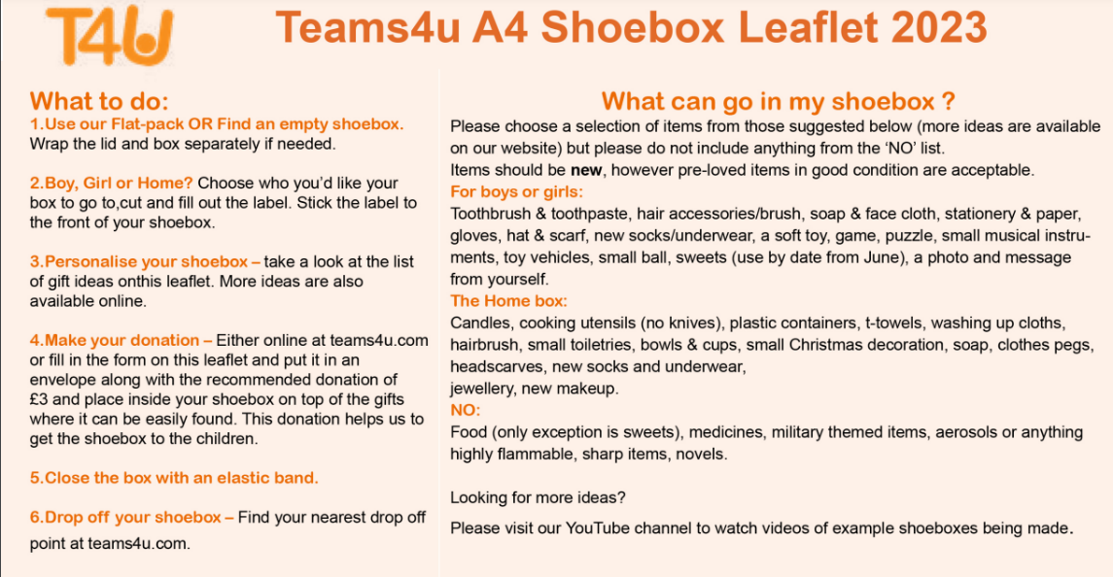
Your shoebox will be given to a vulnerable child, or family, through schools, nurseries, hospitals and orphanages. Our aim is that each box is given in relationship with the local community as part of a long-term commitment to these children. Please be a part of this ongoing story that is continuing to impact and change lives by donating a shoebox to this year’s appeal!
“Christmas is coming, and, right now, I think, children need us to be more present for them. Now is the biggest need.” – Dima Nachyna

Where do the shoeboxes go?
This year the shoeboxes will be heading to the Ukraine, Moldova, Georgia, Bosnia and Romania.

Please can shoeboxes be in school by November 28th.

For more information, please visit https://teams4u.com/shoe-box-appeal-2023/

Miss Jones, Mrs Evans, Mr Williams, Miss H Parkinson.

