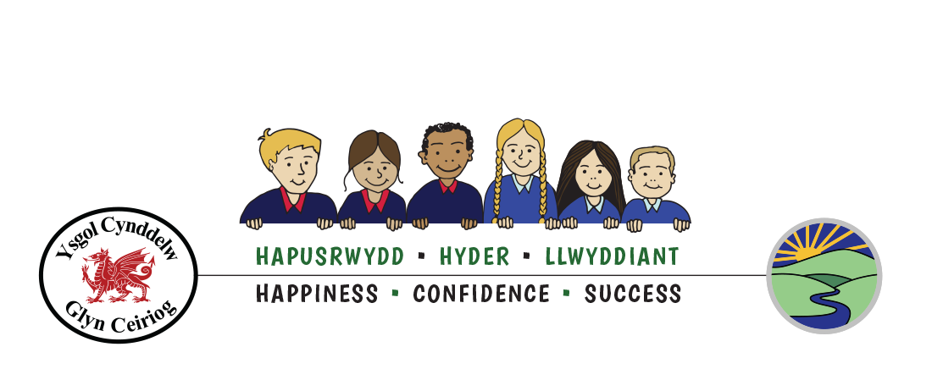

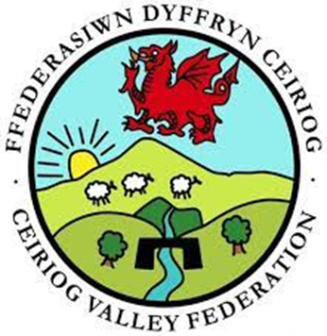

Ffederasiwn Dyffryn Ceiriog
Ceiriog Valley Federation

School Uniform Policy
_______________________________________________
Approved by Governing Body on | Date: April 2024
Due for review on | Date: April 2027
Signed by Chair of Governing Body
(Print name)

School Uniform & Appearance Policy
All children are encouraged to wear and respect their school uniform as proud members of the Ceiriog Valley Federation, Ysgol Cynddelw & Ysgol Llanarmon Dyffryn Ceiriog. We have an expectation of good standards of appearance, tidy dress, and personal presentation. The governors’ policy is that costs are kept to a minimum and parents have a choice of uniform providers where possible.
It is our school policy that all children are encouraged to wear school uniform when attending school, or when participating in a school-organised event outside normal school hours. We provide a complete list of the items needed for school uniform in our school prospectus, and offer good quality items of recycled uniform.
Aims and objectives
Our policy is based on the notion that school uniform:
• promotes a sense of pride in the school, supporting and promoting our ethos;
• engenders a sense of community and belonging towards the schools;
• supports positive behaviour and a sense of respect;
• is practical and smart, ensuring children are dressed appropriately for learning activities;
• identifies the children with the schools;
• removes peer pressure to dress in ‘designer’ fashions;
• ensures due regard is given to securing equality, enabling children of all backgrounds to share a common identity;
• is regarded as good value for money by most parents;
• is designed with health and safety in mind.

Uniform
Ysgol Cynddelw
Navy tailored shorts / pinafore/skirt/trousers,
Navy sweatshirt/cardigan/jumper
Red polo shirt
Pupils are also welcome to wear Red and White check dress (optional)

Ysgol Llanarmon Dyffryn Ceiriog
Black tailored shorts / pinafore/skirt/trousers,
Royal Blue sweatshirt/cardigan/jumper
Sky blue / light blue polo shirt
Pupils are also welcome to wear blue and White check dress (optional)

Black shoes / trainers for all children. Open toe footwear is not permitted.

Physical activity/ P.E.
Physical Education is an important part of school life, assisting with general health
and the wellbeing of young people. For indoor activities children are encouraged to wear Navy/black shorts and a white T-shirt. Bare feet for gym and dance.

For outdoor games / activities, children wear Navy/black shorts and white T-shirt and
trainers. A tracksuit or jogging suit with trainers is advised in colder weather.
Forest School activities:
It is imperative the children come to school appropriately dressed for these sessions as the children are generally out for the whole session regardless of the weather.
Cold Weather
- waterproof coat and trousers
- warm underlayers e.g. jumpers, fleeces, extra socks
- wellington boots or snow boots
- gloves and a scarf in winter months
Warm Weather
- long sleeved tops and long trousers
- sun hats or a cap
- sturdy outdoor footwear e.g. trainers or boots
- sunscreen
Parents are given sufficient notice of any outdoor activity or visit which requires specific items of clothing, for example Y3-6 children may require shin pads for football and hockey.
For swimming lessons, children are asked to bring a towel, suitable swimwear and
goggles/swim hat should they wish.

Parents are respectfully asked and regularly reminded to label all items of clothing /
footwear with their child’s name.

Jewellery
For health and safety reasons we do not allow children to wear jewellery in our school.
The exceptions to this rule are small stud ear-rings in pierced ears and watches. We
encourage the children to remove these during PE and games for their own safety.
Hairstyles:
Extreme hair fashions are discouraged. These will be discussed with parents if the need arises. Long hair should be tied back neatly. We ask for the full support of parents regarding this matter.
The role of parents
We ask all parents who choose to send their children to our school to support the
school uniform policy. We believe that parents have a duty to send their children to
school correctly dressed and ready for their daily schoolwork. One of the
responsibilities of parents is to ensure that their child has the correct uniform, and
that it is clean and in good repair.

Equality
The school welcomes children regardless of sex, race, religion, belief or disability. If
there are serious reasons, for example on religious grounds, why parents want their
child to wear clothes that differ from the school uniform, the governing body will act
reasonably in accordance with such requests. The school will also discuss possible
temporary / permanent medical reasons for such requests. The head teacher will
discuss such requests with parents.

The role of the headteacher
The headteacher has overall responsibility for the day-to-day running of the school,
including upholding the school uniform policy.
The headteacher will decide what action to take when pupils infringe the school
uniform and appearance policy. The headteacher will always try to establish why a
pupil is not complying with school policy and will offer to loan items of uniform.
Where, and when appropriate the headteacher may contact parents/carers to offer
support in providing the school uniform.

If breaches of the school’s policy are persistent and in open defiance of the school’s
uniform and appearance policy, and where all other avenues for resolving this
dispute have been exhausted, the school will consider external legal advice.

The role of governors
The governing body supports the headteacher in implementing the school uniform
policy. It considers all representations from parents regarding the uniform policy and
liaises with the headteacher to ensure that the policy is implemented fairly and with
sensitivity.
It is the governors’ responsibility to ensure that the school uniform meets all
regulations concerning equal opportunities.
Governors ensure that the school uniform policy helps children to dress sensibly, in
clothing that is hardwearing, safe and practical.

Complaints
Complaints about school uniform and appearance codes / policies are dealt with in
accordance with the governing body complaints procedure.

